SHARES
Pearson Edexcel - Monday 14 November 2011 - Paper 4 (Calculator) Higher Tier
1.
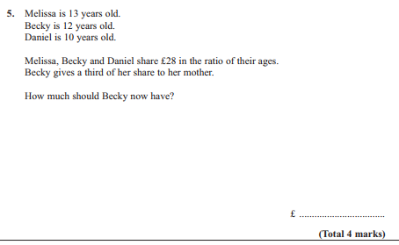
Pearson Edexcel - Monday 6 June 2011 - Paper 3 (Non-Calculator) Higher Tier
2.
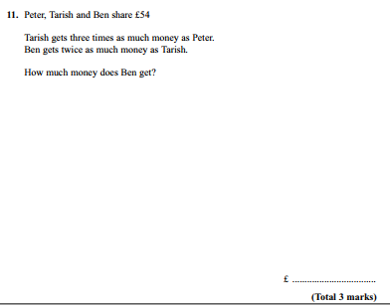

Pearson Edexcel - Monday 7 June 2010 - Paper 3 (Non-Calculator) Higher Tier
3.
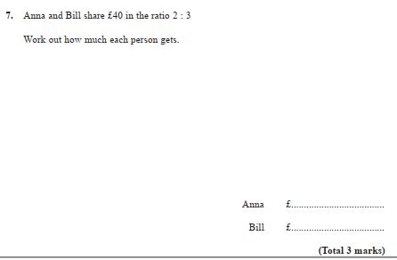
4.

